MINI PROJECT + REPORT

NAME: - ROLL NO

HAMID MUSTAFA Group Leader2K17/SWEE/22

MUHAMMAD HASSAN 2K17/SWEE/47

SUBJECT: - HUMAN COMPUTER INTERACTION

ASSIGNMENT Mini project + report

SUBMITTED TO: - Sir Sundar Ali Khawaja

DEPARTMENT: - SOFTWARE ENGINEERING(E)

FACULTY: - FACULTY OF ENGINEERING AND . TECHNOLOGY

**INTRODUCTION:**

This mini project entitled with the “PENSION CALCULATOR” is based on java language we have the used the java. Swing library for the GUI and we have added some dummy data using the MySQL database for the interaction with the system.

Actually, this mini project gets the information from the user like his/her “PROVINCE”,” DEPARTMENT” and CNIC No only to calculate the his/her “GROSS PENSION” and “NET PENSION”.

**IDENTIFYING THE TASK: -**

The identification of task in this system because any person with normal eyesight 😉 can see the label above on the form which is

**Interaction of system with user: -**

While filling the form the system also interacts with the user to achieve his/her by showing some guide alerts.

For example, while filling the form the user mistakenly enters an alphabet in the CNIC TEXTFIELD the system will show an alert msg like this

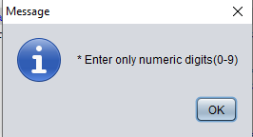

Or if any required information is not given then it will show this

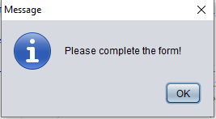

**Reflections from the views of the user: -**

I give this system to 17 person who don’t know very much about the computer some of them don’t know how to use the computer or do anything on the computer they all are government employees I ask them to use this “Pension calculator ” to calculate your pension (GROSS , NET) they entered there basic information like CNIC,NAME,PROVINCE,DEPARTMENT,LAST SALARY DRAWN during the filling the form they asked me the form is to long so noted that point and I changed the GUI of this system and reduce the input fields from 15 textfield to 3 textfield.

So, we again give them the system to calculate his/her PENSION (GROSS, NET) So now they used this system very easy to calculate the pension.

When they filled the form then clicked the “SUBMIT” button after button clicked a popup/message-dialog will open to verify the information they have provided during the form filling like this in image.

If they clicked the “NO” button, then they have to fill their form with right information again.

If they verify their information and clicked the “YES” button, then they will proceed to the next frame where his/her information is given automatically like showed in this image

Where they can see their full information, which is provided by his/her department.

There are buttons on the form if the user wants to calculate another pension then the user has to click the

“Calculate Again?” button otherwise click the “CLOSE” button.

THANKS